
Egypt University of Informatics
Computer and Information Systems
Data Analysis Course

The Analysis of The Impact of Lifestyle on Academic Performance
Submitted by: Ali Walid, Arwa Ayman, Hana Kamal, and Malak Khaled

Introduction

This analysis is about how different lifestyles affect academic performance. It highlights the relation between study hours, sleep patterns, ect. To find out which factors have the highest impact on academic outcomes

Research Question

Is there a relationship between lifestyle habits and academic performance?
- Does regular physical activity improve GPA outcomes?
- Does getting enough sleep reduce stress and improve academic performance?
- Which lifestyle factor is the strongest predictor of GPA?

Hypothesis
H₀ Null Hypothesis: Lifestyle habits have no significant effect on students’ GPA
H₁ Alternative Hypothesis: Students who get more sleep, have higher study hours, lower stress levels, and regular physical activity have significantly higher GPAS

Population of Interest:
The population of Interest is students whose academic performance may be influenced by their lifestyle

Sampling Method:
The dataset used is collected from Kaggle it represents a sample of students. This method is considered a convenience sampling method as the data was already collected and available

Bias Identification:
Self-reporting bias: Students may not be reporting accurately about their stress levels or study hours
Selection bias: The dataset may not include students from all backgrounds
Response bias: Participants may answer questions in a way that is deemed socially acceptable
To minimize the bias, we assume that data cleaning was performed to remove inconsistencies. The analysis focuses on generality rather than absolute conclusions.

Survey Questions/Collected Data/Dataset:
The dataset includes multiple variables such as: GPA, study hours, sleep hours, stress levels, physical activity (frequency of exercise per week), and social engagement (the level of social interactions)
The number of samples used: 2000

Analysis:
To analyse the dataset, we used descriptive statistics and visualizations such as box plot, scatter plots, and heatmaps.
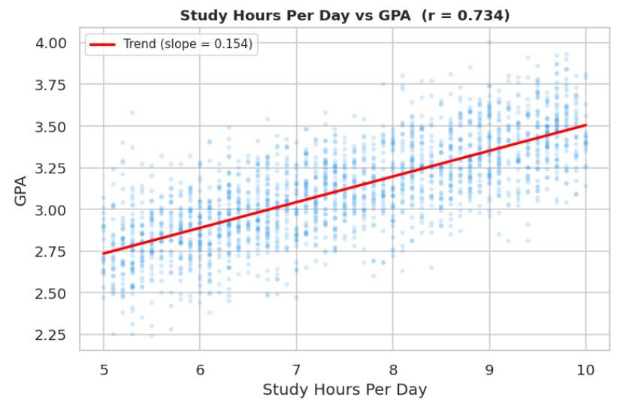
Scatter Plot Showing the relationship between study hours and GPA. Observing a positive trend where students who study more tend to have a higher GPA this suggests that study time is an important factor
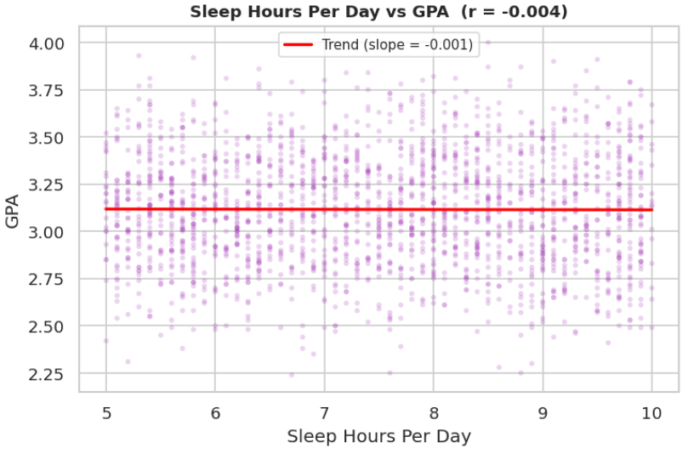
This scatter plot shows how sleep duration affects GPA students who get enough sleep generally have a better academic performance
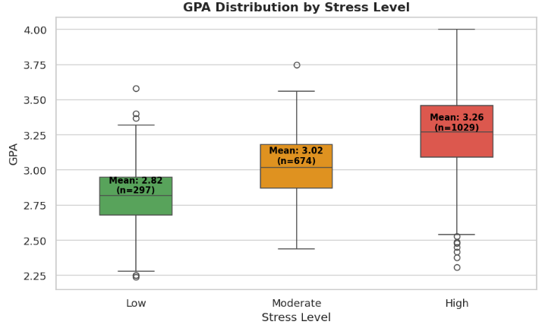
This box plot shows that contrary to popular belief, students with higher stress levels tend to have higher GPAs
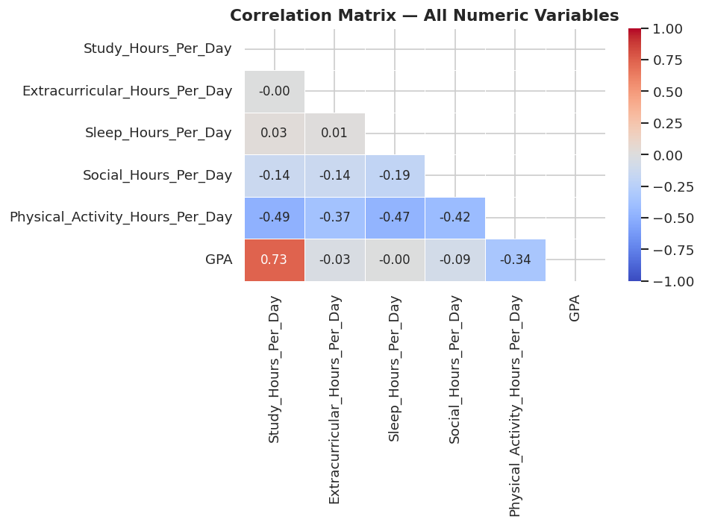
The heatmap summarizes the relationship between all variables

Hypothesis Testing Steps
- Step 1: Define the null and alternative hypotheses
- Step 2: Choose a significance level
- Step 3: Preform Statistical analysis
- Step 4: Compare the p-value with α and decide whether to reject H₀

Conclusion
The analysis suggests that lifestyle habits do have an impact on academic performance. Study hours and sleep show positive relationships with GPA, while stress has a negative effect.
Based on the results we reject the null hypothesis and accept the alternative hypothesis where lifestyles significantly influence academic outcomes.

Any potential issues
-The dataset may not represent all student populations.
-Self-reported data may not be fully accurate.
-Some variables (like stress) are subjective.
-External factors (e.g., teaching quality, personal issues) are not included.

